**Life expectancy**

It is a statistical measure of the average (see below) time an organism is expected to live, based on the year of its birth, its current age, and other [demographic](https://en.wikipedia.org/wiki/Demographic) factors including [biological sex](https://en.wikipedia.org/wiki/Sex). The most commonly used measure is life expectancy at birth (LEB), which can be defined in two ways. Cohort LEB is the mean length of life of an actual birth [cohort](https://en.wikipedia.org/wiki/Cohort_(statistics)) (all individuals born in a given year) and can be computed only for cohorts born many decades ago so that all their members have died. Period LEB is the mean length of life of a [hypothetical](https://en.wikipedia.org/wiki/Hypothesis) cohort assumed to be exposed, from birth through death, to the [mortality rates](https://en.wikipedia.org/wiki/Mortality_rate) observed at a given year.

 In the [Bronze Age](https://en.wikipedia.org/wiki/Bronze_Age) and the [Iron Age](https://en.wikipedia.org/wiki/Iron_Age), human LEB was 26 years; the 2010 world LEB was 67.2 years. In recent years, LEB in [Eswatini (Swaziland)](https://en.wikipedia.org/wiki/Eswatini) is about 49, while LEB in [Japan](https://en.wikipedia.org/wiki/Japan) is about 83. The combination of high [infant mortality](https://en.wikipedia.org/wiki/Infant_mortality) and deaths in young adulthood from accidents, epidemics, plagues, wars, and childbirth, particularly before modern medicine was widely available, significantly lowers LEB. For example, a society with a LEB of 40 may have few people dying at precisely 40: most will die before 30 or after 55.

[“Life Expectancy” – What does this actually mean? - Our World in Data](https://ourworldindata.org/life-expectancy-how-is-it-calculated-and-how-should-it-be-interpreted)

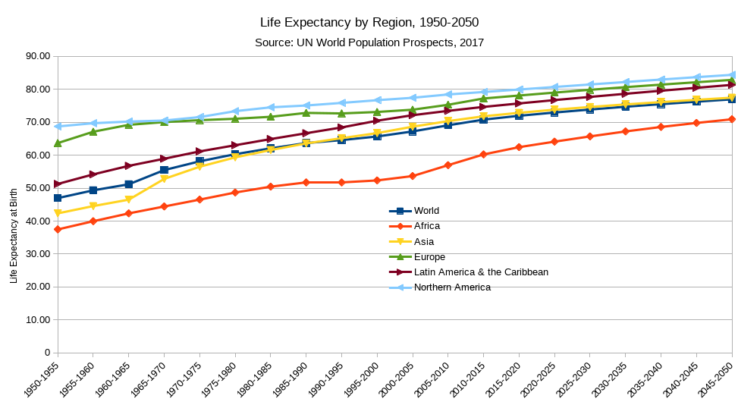

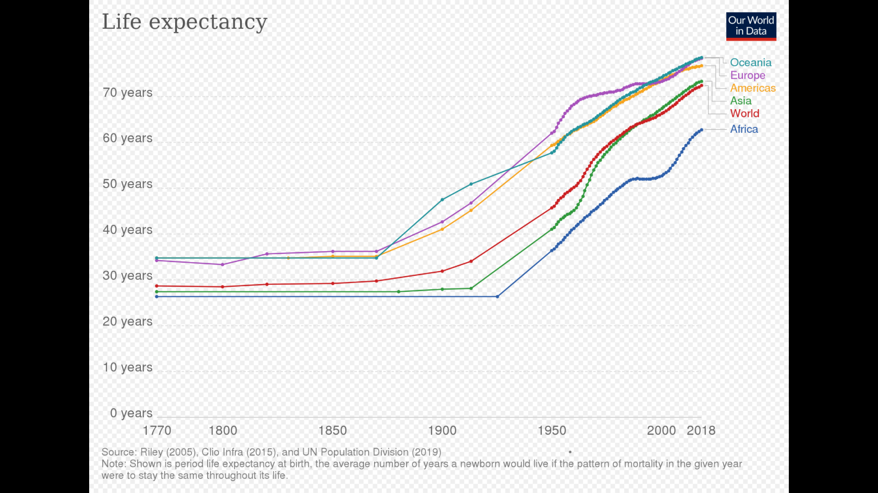

**How is life expectancy calculated?**

In practical terms, estimating life expectancy entails predicting the probability of surviving successive years of life, based on observed age-specific mortality rates. How is this actually done?

Age-specific mortality rates are usually estimated by counting (or projecting) the number of age-specific deaths in a time interval (e.g. the number of people aged 10-15 who died in the year 2005), and dividing by the total observed (or projected) population alive at a given point within that interval (e.g. the number of people aged 10-15 alive on 1 July 2015).

To ensure that the resulting estimates of the probabilities of death within each age interval are smooth across the lifetime, it is common to use mathematical formulas, to model how the force of mortality changes within and across age intervals. Specifically, it is often assumed that the proportion of people dying in an age interval starting in year  and ending in year  corresponds to , where  is the age-specific mortality rate as measured in the middle of that interval (a term often referred to as the ‘central death rate’ for the age interval).[1](https://ourworldindata.org/life-expectancy-how-is-it-calculated-and-how-should-it-be-interpreted#note-1)

Once we have estimates of the fraction of people dying across age intervals, it is simple to calculate a ‘life table’ showing the evolving probabilities of survival and the corresponding life expectancies by age. [Here is an example of a life table from the US](https://ourworldindata.org/uploads/2017/07/Example-Life-Table-US.png), and [this tutorial from MEASURE Evaluation](https://www.measureevaluation.org/resources/training/online-courses-and-resources/non-certificate-courses-and-mini-tutorials/multiple-decrement-life-tables/lesson-3) explains how life tables are constructed, step by step (see Section 3.2 ‘The Fergany Method’).

Period life expectancy figures can be obtained from ‘period life tables’ (i.e. life tables that rely on age-specific mortality rates observed from deaths among individuals of different age groups at a fixed point in time). And similarly, cohort life expectancy figures can be obtained from ‘cohort life tables’ (i.e. life tables that rely on age-specific mortality rates observed from tracking and forecasting the death and survival of a group of people as they become older).

For some countries and for some time intervals, it is only possible to reconstruct life tables from either period or cohort mortality data. As a consequence, in some instances—for example in obtaining [historical estimates of life expectancy across world regions](https://ourworldindata.org/grapher/life-expectancy-globally-since-1770)—it is necessary to combine period and cohort data. In these cases, the resulting life expectancy estimates cannot be simply classified into the ‘period’ or ‘cohort’ categories.

